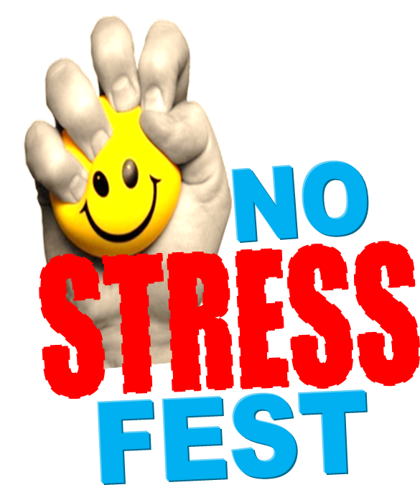

Registration
Relaxation Corner
Stress-Less Zone
Passport Event

Enter to Win

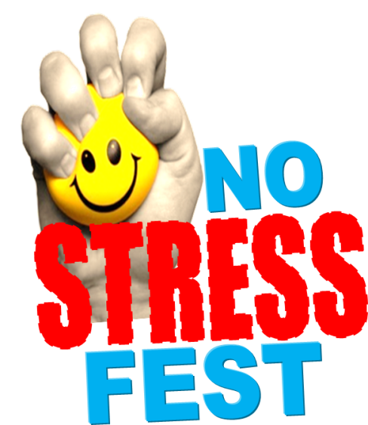
Please Wipe Equipment After Use

Breastfeeding Friendly

Breastfeeding Area

Photo Booth

